**Britain has no need to make an apology to India for Empire...**

**Daily Mail  
By** [**NIRPAL DHALIWAL**](http://www.dailymail.co.uk/home/search.html?s=y&authornamef=Nirpal+Dhaliwal) **30 July 2010**



Many have interpreted David Cameron's statement that he is visiting India in a 'spirit of humility' as a shame-faced apology for Britain's imperial rule there. But Indians require no apology for Empire and seek none, and nor do Britons need to feel especially guilty for it.

India is the world's second-largest growing economy, producing more English-speaking graduates than the rest of the world combined.

The use of English is the most enduring and profitable legacy of the Raj; without it, the boom in Indian call-centre and software industries could not have happened.

We need close ties with India to increase our own prosperity, but India needs us, too.

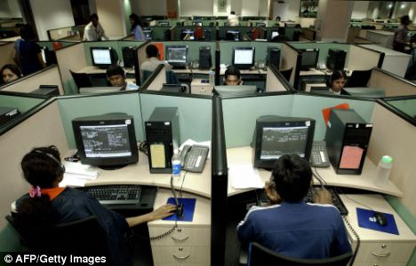

*Industrial boom: The rapid rise in India-based call centres and software industries has made the country the second-largest growing economy*

Close ties with Britain give India better access to the rest of Europe. Just as Empire opened the doors of modernity to India, a good relationship between Britain and India will be a mark of how prominent both countries are in the modern world.

It is a subject that particularly interests me as, although I was born and raised in Britain, my parents migrated here from India.

In recent years, I have spent much time travelling and working in the sub-continent, wanting to understand what it means to me; that journey surprisingly led me to also realise just how much more Britain means to both me and India.

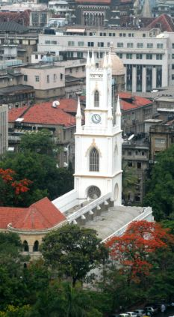

*Proof: St Thomas Cathedral in Mumbai shows a quiet acknowledgment that British rule left a helpful legacy*

All that is best about India - its tolerance, freedom and engagement with the world - has flourished due to the structures and ideas it inherited from British rule.

Last Christmas, I attended midnight mass at St Thomas's Cathedral in Mumbai. Built in 1718, it is the oldest colonial building in the city, pre-dating the Raj by over a century, and is a monument to Empire.

As the Church of India priest lead a service that any British Anglican would recognise, I read the plaques covering the walls, which commemorated officers of the East India Company who fell in the various battles through which Britain defeated and subjugated India.

The fact that Christianity is very much accepted in India (the next day, the neon sign outside the Mahalakshmi Temple proclaimed 'Merry Christmas' to its Hindu worshippers), is proof of the country's quiet acknowledgement that British rule in India left a legacy that unified its disparate peoples and enabled them to emerge as a power in the world.

Despite the often callous profiteering of Empire, the modern Indian state simply would not exist without it.

Like the U.S., India is a nation fostered into being by Britain, and one which derives its romantic national identity from its struggle for independence. And just as Americans don't publicly admit that George Washington was an abysmal general who lost almost every battle, Indians don't explicitly recognise Britain's contribution to their country's present success.

But emulation is the sincerest form of flattery, and the fact that since 1947, Indians have built upon much of what Britain introduced them to - the English language, parliamentary democracy, the rule of law and the protection of individual rights - is an admission of the crucial role this country played in their history.

Of course, Empire was not a purely altruistic enterprise. Britain reaped enormous profits from India at the expense of its growth.

It prohibited industrialisation and kept the vast bulk of Indians in a state of abject poverty, growing cotton or mining metals that would then be sent to the factories and mills of northern England.

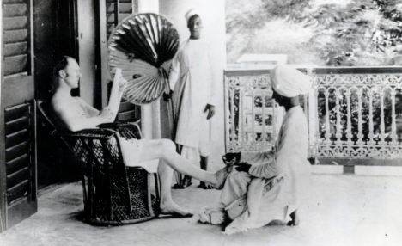

*British Raj: The life of a British Army officer during the early days of British rule in India, which was between 1858 and 1947*

India's first post-independence census showed the population to be 80 per cent illiterate, with a typical life expectancy not exceeding 40.

But these bleak facts should not obscure the fact that British rule in India was a joint effort, impossible without the widespread co- operation of Indians themselves.

Despite the country's vast population, there were never more than 70,000 British troops in India; the running of the country required an enormous infrastructure of native troops, police and bureaucrats. As Hitler observed, Indians merely had to spit all at once and every Briton in India would have drowned.

Indians assisted with Empire because it brought them unprecedented order and civility. Indians were no strangers to outside rulers; for eight centuries before the Raj, the sub-continent had been subjected to the plunder and depravity of the Mughals - Muslim rulers who came from as far west as Turkey.

Delhi was razed eight times in that period and great pyramids were constructed with the skulls of its inhabitants.

Because Islam permits the enslavement of non-Muslims, Indians were sold across the Islamic world in such quantities that the international price of slaves collapsed.

The Afghan mountain range of the Hindu Khush (which translates as the 'Hindu Slaughter') is named after the huge numbers who died there while being marched to the markets of Arabia and Central Asia.

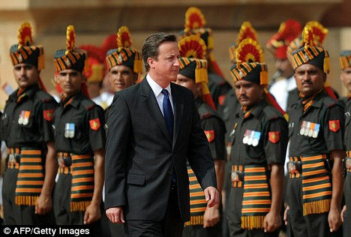

*Honour guard: David Cameron at the Presidential Palace in New Delhi this week*

For all the artistic refinement and opulence of India's past rulers - and their poetry, music, and the magnificence of the Taj Mahal are testament to that - they oversaw a period of general barbarism in which the ordinary Indian was no more than a starving chattel.

The rebellions which eventually arose against the Mughals - such as the Sikhs in Punjab and the Marathas in the south - fractured the rulers' power, and enabled the British to get their own foot in the door.

At this point, it's important to remember that the British did not arrive in an idyllic sub-continent full of happy, contented Indians, but in one in extreme turmoil.

And, though primarily motivated by profit, they sought to apply humane values - even if at gunpoint.

In 1846, the British commissioner, John Lawrence, told the local elite that Punjabis could no longer burn their widows, commit female infanticide, nor bury their lepers alive.

When they protested, saying that he had promised there would be no interference in their religious customs, Lawrence steadfastly replied that it was British religious custom to hang anyone who did such things.

In addition to combating these barbaric practices, the British also outlawed slavery in 1843 at a time when an estimated 10 million Indians were slaves - up to 15 per cent of the population in some regions.

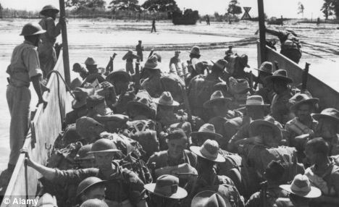

*Volunteers: When the call came, two million Indians, such as those of the 15th India Corps, joined the Second World War - the largest volunteer force in history*

Yes, British rule was exploitative and took away more than it provided, but compared to what Indians had known previously, there was much to be thankful for.

This gratitude expressed itself in 1939 when, at the height of the independence movement led by Jawaharlal Nehru and Mahatma Gandhi, two million Indians nonetheless enlisted in the fight against fascism - the largest volunteer army in history.

It's no overstatement to say that, without the British, Indians would not even know what it is to be Indian.

After 800 years of Mughal rule, Hindu culture was in terminal decline and it was the likes of Warren Hastings and William Jones, the founders of the Asiatic Society, who began the collection and renewed study of India's ancient texts, educating Indians about their own rich and unique past.

And it was a Briton, Allan Octavian Hume, who helped found the Indian national Congress - the political party that would eventually lead the country to independence.

Thousands of Indians died building the railways of the Raj, but countless more died building the Taj Mahal and other useless baubles for their earlier rulers.

For all they extracted from India, the British left behind a practical network of transportation, governance and values without which India would not be the dynamic democracy it is today.

It is a mark of India's quiet appreciation as well as its great self-confidence that it asks for no apology for the past.

Out of respect, no Briton should be condescending enough to offer one.